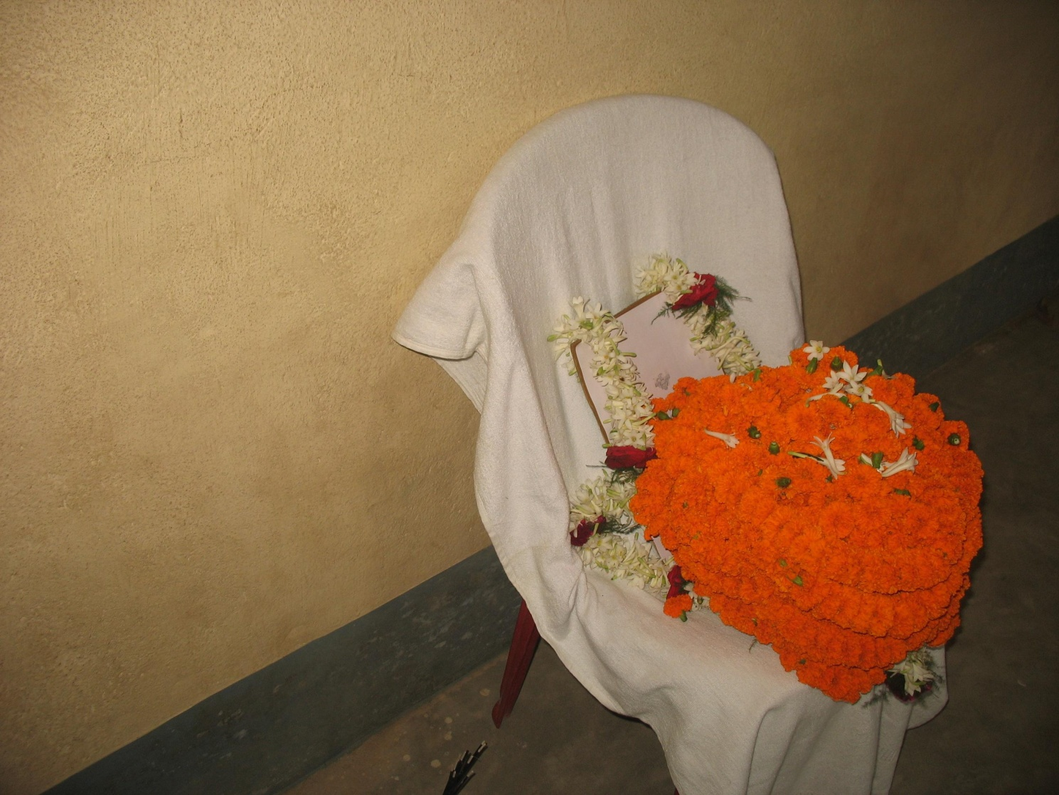

Principal, Staff and Students of Netaji Mahavidyalaya, Arambagh, Hooghly deeply mourn the sad demise of their ex-Principal Sri Sanat Kumar Banerjee who passed away for his heavenly abode on 26.10.2014.
May his Soul rest in Peace.

